Assignment 2

Learning Objectives:

- Learn Naïve Bayes
- Analyze the effect of skewness of distribution of class attribute values on classification performance
- Learn about smoothing
- Get some programming experience (if you take the programming option)

Description:

In this assignment you will work with the Play Tennis data set we have worked with several times.The data from the Play Tennis data set is included here for your reference:

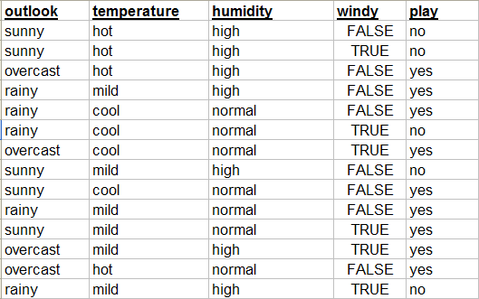

Step-by-Step Guide (Nonprogramming Option):

- List all of the counts you would store for a simple Naïve Bayes model trained from the Play Tennis data set. Note that for this assignment we are adding an additional possible value for the Humidity feature, namely low, which never occurs in the training data. Compute these counts by hand and put them in a table in your answer document.
- Now construct a second table from the same data using a form of smoothing where you simply add 1 to all counts.

- Compute your prediction for the following test instances using Naïve Bayes applied to the two tables above so that you have a prediction with the original model and with the smoothed model, and show all of your work. Comment on the impact of zero counts on predictions. Comment on the impact of smoothing on prediction.

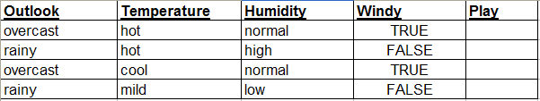

- You will turn in a write up with your answers to questions 1-3.

Step-by-Step Guide (Programming Option):
- You should already have Python installed on your computer from Assignment 1. Download and unpack thinkbayescode.zip from blackboard. Most of this code came from the freely available code that comes with the Think Bayes book. I just added amlnaivebayes.py.
- Read Supplementary Stat Reading 2, which you will find in the Assignment 3 folder near the thinkbayescode.zip file. This is an excerpt from Chapter 2 of the Think Bayes book, which begins to describe how Naïve Bayes works and how it is implemented in a simple way for the Cookie problem.
- Launch Python with the working directory set to your thinkbayescode folder. Load the thinkbayes.py file. You can do this with execfile(‘thinkbayes.py’)
- Now, read through amlnaivebayes.py and compare it with cookie2.py, which is described in Supplementary Stat Reading 2, and which can be found in thinkbayescode/thinkbayes_code.
- What you are going to do is compute a probability for each class value for each instance in the following table, both with a model that does not use smoothing and one that does. You’ll do this by following the instructions in the comments in the amlnaivebayes.py file for modifying 3 functions, then running the file using execfile(‘amlnaivebayes.py’) and then copying the output into a text file.

- You will turn in your modified version of amlnaivebayes.py and your text file with the results. Also, answer the following question: What do you notice is the impact of smoothing on prediction.

Deliverables:

- Submit your answers for Part 1 according to the specifications of the nonprogramming or programming option, depending on which you selected.

